Tatyana Vlaskin
Assignment 0: Part 2: Environment Setup
SCREENSHOT OF Code:Blocks- program was compiled
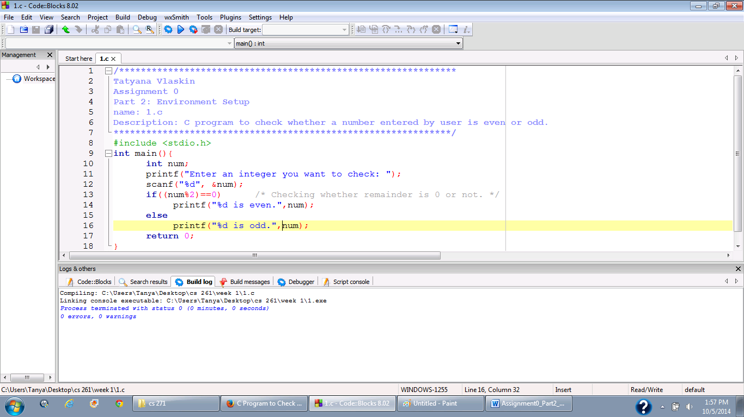
SCREENSHOT OF Code:Blocks- program was compiled and run 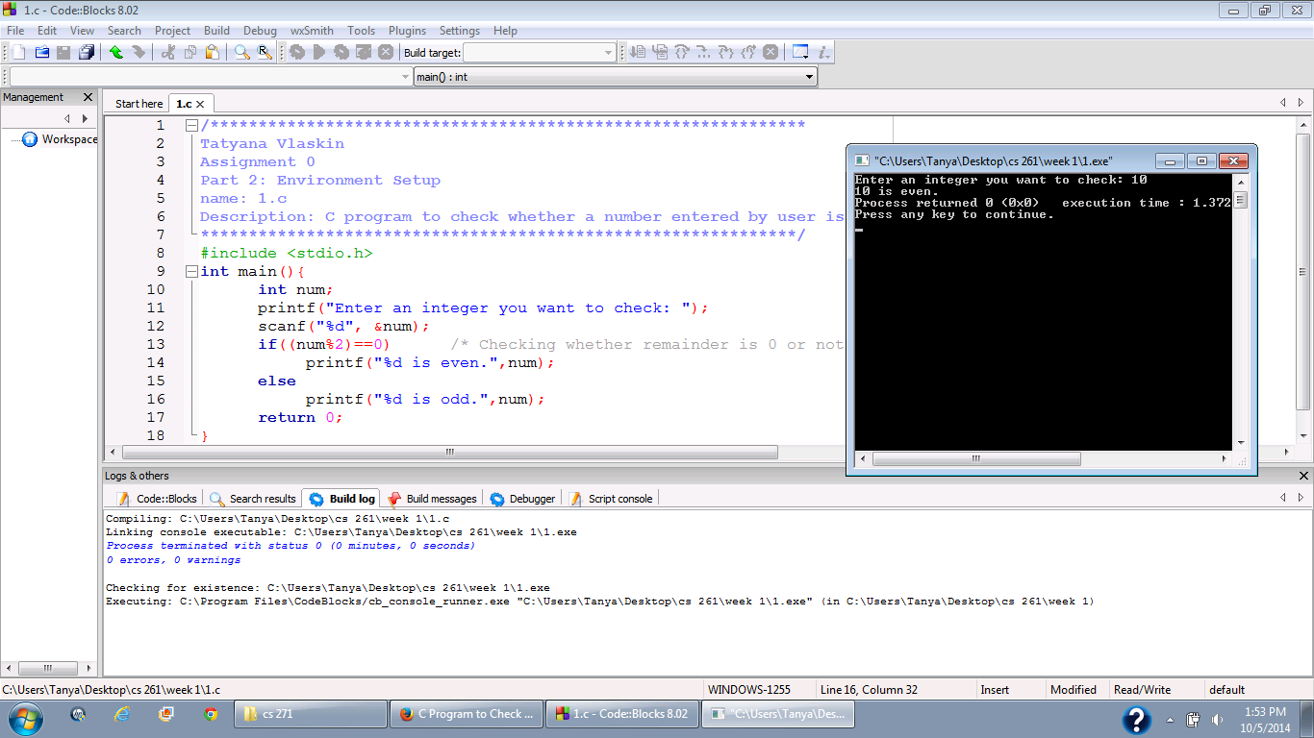
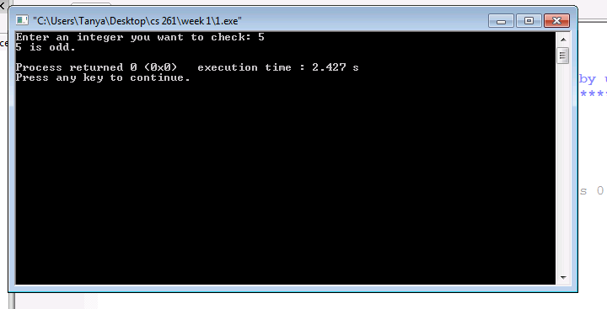
For Putty I found the following website to be very valuable: http://www.chiark.greenend.org.uk/~sgtatham/putty/faq.html#faq-cutpaste
- Writing a program on Flip Server: Open a file with any editor ( command: pico test.c) , which is a Unix like Notepad.
- Write you first c program there .
- Save it – CTRL+ o
- Exit – CTRL+x

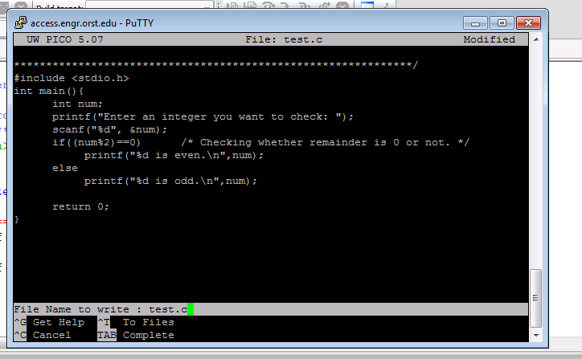

Compilation on the Flip Server:
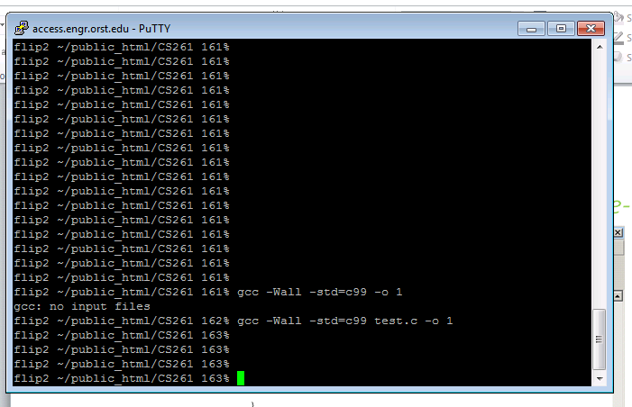
Running on the Flip Server:
